|  |  |
| --- | --- |
| PHY 477/577: Obs. Methods & Data Analysis in Phys. Ocn. | Derek J. Grimes |
| Assignment 6: Auto-Spectral & Cross-Spectral Analysis  Carter Beaulieu | grimesdj@uncw.edu |

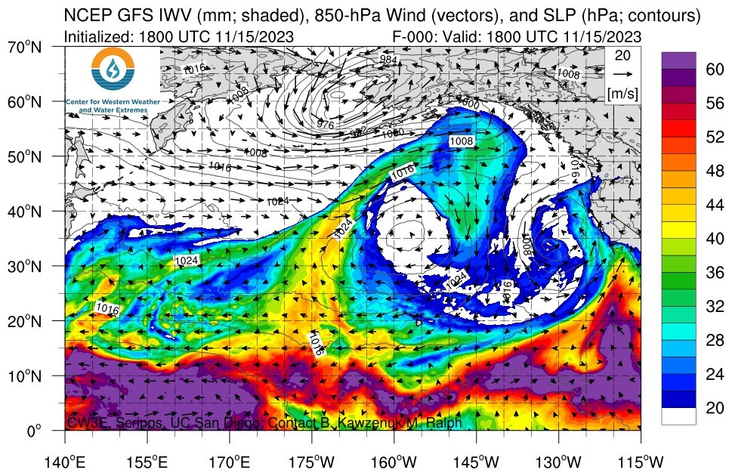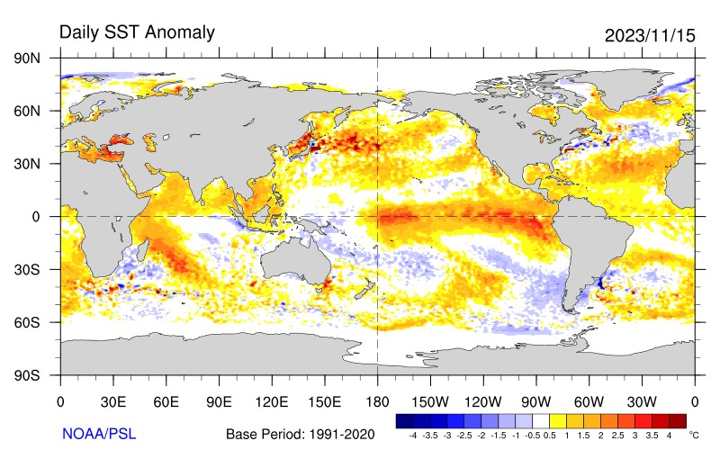

Figure 1: Sea-surface temperature anomaly ([https://psl.noaa.gov/enso/)](https://psl.noaa.gov/enso/) relative to the 1991-2020 mean temperature, with the ENSO-3.4 region shaded in dark gray. Integrated total water vapor with sea-level pressure contours over the North Pacific ([https://psl.noaa.gov/arportal/)](https://psl.noaa.gov/arportal/), with the NPI region shaded in dark gray.

Goal: develop code to implement Welch’s method for estimating auto- and cross-spectral amplitudes for two climate records.

Task: Global climate has many patterns of variability. The co-variability between different regions are called “teleconnections” because changes in climate (precipitation, temperature, etc.) are mediated by the fresh-water cycles, seasons, and oceanic & atmospheric transport pathways. There are some locations where small changes in conditions have nearly a global impact on climate. We use these signals or “indices” to predict climate shifts, *e.g.,* whether North America will be warm and wet, or dry, or ...Here, you’ll download two records used as climate indices: ENSO-3.4 ([https://www.cpc.ncep.noaa.gov/data/ indices/ersst5.nino.mth.91-20.ascii)](https://www.cpc.ncep.noaa.gov/data/indices/ersst5.nino.mth.91-20.ascii) and PNI ([https://climatedataguide.ucar.edu/sites/default/files/2023-10/ npindex](https://climatedataguide.ucar.edu/sites/default/files/2023-10/npindex_monthly.txt) [monthly.txt)](https://climatedataguide.ucar.edu/sites/default/files/2023-10/npindex_monthly.txt). The El Nino Southern Oscillation-3.4 index is based on the average water temper-˜ ature between −5◦-5◦ N and 170◦-120◦ W (left, Figure 1). When this region is anomalously warm, we are entering (or are in) an El Nino phase; whereas, when its anomalously cold, we’re in a La Ni˜ na phase.˜ The North Pacific Index is based on the sea-level-pressure between 30-60◦*N* and 160◦E-140◦W (contours, right, Figure 1). When the average atmospheric pressure over this region is low, the west-coast of the US gets more winter rainfall, and vice-versa. Your mission is to evaluate whether these remote locations have coherent variability, and the associated time-scales and phases.

1. Download and ingest the two records, monthly sea-surface temperature *T* at ENSO-3.4 and monthly sea-level pressure *p* at NPI. Trim the records so that they overlap and appropriately interpolate over or remove nan’s.
2. A graph of a pressure and a pressure

   Description automatically generated with medium confidencePlot both records on separate axes. Describe the time-series (zoom in if needed). What are their mean, and standard deviations, and zero-lagged correlation coefficient? Is the correlation coefficient statistically significant? Use the Fisher-transformation from Lecture 5.

monthly_stats_enso_df: Month Average_SST Std_Dev_SST

Date

1 1 26.401081 1.098468

2 2 26.610405 0.907493

3 3 27.117703 0.701512

4 4 27.571892 0.620953

5 5 27.691351 0.623093

6 6 27.513919 0.629037

7 7 27.087703 0.694642

8 8 26.676216 0.794544

9 9 26.566622 0.891244

10 10 26.534730 1.034100

11 11 26.494521 1.113494

12 12 26.437808 1.146546

monthly_stats_pni_df: Month Average_Pressure Std_Dev_Pressure

Date

1 1 1007.134960 4.571098

2 2 1008.076720 4.319386

3 3 1012.358720 3.522838

4 4 1014.802720 2.674045

5 5 1014.984960 1.560272

6 6 1015.203840 1.433183

7 7 1017.526800 1.218407

8 8 1016.448720 1.328343

9 9 1014.423548 1.510533

10 10 1012.598468 1.907398

11 11 1011.067339 2.913205

12 12 1008.218699 3.581755

The correlation is statistically significant (z-statistic: 6.1889)

Correlation Coefficient: 0.20531198013907961

Zero-lagged correlation coefficient between SST and Pressure: 0.20531198013907961

1. Estimate the auto-spectral density functions *STT* & *Spp* for each record, using *M* = 18 windows each with *Nc* = 128 data-points and *β* = 2*/*3 overlap. How many degrees of freedom do you have? Estimate the corresponding 95% confidence interval.

Degrees of Freedom for ENSO: 36

95% Confidence Interval for ENSO: (1.6773061033839565, 0.6612881615241248)

Degrees of Freedom for PNI: 36

95% Confidence Interval for PNI: (1.6836957842249138, 0.6579943269558135)

1. Estimate the cross-spectral density function *STp* for each record, using the same {*M,Nc,β*}.

Degrees of Freedom for Cross-Spectral Density: 36

95% Confidence Interval for Cross-Spectral Density: (0.6594790868068361, 1.6808763804327618)

1. Plot your auto-spectra and cross-spectra versus cyclic frequency (in cycles/year) on the same log-log axes, include your confidence interval.

1. Describe the auto-spectra:
   * are they red, white or blue?

Red, white and blue spectrum references the power/frequency distribution. Red spectrum lower frequency, white indicates relatively even distribution, blue signal is concentrated at higher frequencies. The auto-spectrum of ENSO is definitely a red spectrum demonstrated by the high spectral density peaks at lower frequencies. The auto-spectrum of PNI is slightly more blue then then ENSO spectrum but would say it is still predominantly red, as it too has a sole large peak at a relatively low frequency.

* + do they have any significant peaks? If so, at what time-scales

The ENSO, PNI, and cross spectrum show a significant peak around 75 years and a smaller peak around 30 years.

* + Are there any peaks in the cross-spectrum that are different than either auto-spectrum?

There are not any peaks in the cross-spectrum that are different in either auto-spectrum. Cross spectrum seems to capture the significant peak at 1 cycle every 75 years from the ENSO auto-spectrum, and the peak at 1 cycle every 30 years from both the ENSO and PNI auto-spectrum.

1. Plot the coherence *γ*ˆ2 and phase *ϕ*ˆ on a linear scale versus frequency on a log10 scale. Estimate the threshold for 95% bound on a truly zero coherence *γ*2 = 0. Only over the regions where *γ*ˆ2 is larger than this threshold, estimate and plot error bars for the 95%-CI bounds for the estimate.

1. Are there any frequencies with significant coherence? What are the corresponding time-scales? Describe the patterns in coherence, and the corresponding phase. What is the phase for time-scales longer than 5 years? How does this relate to the *T* and *p* anomolies, *e.g.,* at these time-scales when *T*′ = *T* − *T >*¯ 0 then *p*′ = *p* − *p*¯????

Significant coherence occurs around the 1 cycle every 75 years, and one cycle every 40 years with the corresponding phase being approximately 0 at the peak at 1 cycle every 75 years and is approximately negative 4. The phase fluctuates between negative and positive, however for time-scales longer than 5 years the phase is usually negative which suggests that changes in temperature tend to follow changes in pressure.

1. A graph of a low-cost loss

   Description automatically generated with medium confidenceLow-pass filter the records, *Tlp* = *T ⋆ w* & *plp* = *p ⋆ w*, to remove variations on time-scales shorter than 2-years. Plot them similar to question (2) above. What is the correlation coefficient between the low-passed records? How does this compare to the coherence estimate *γ*ˆ2? Is the relationsip between *Tlp*′ and *p*′*lp* consistent with your rationale in question (9)? Explain why/not. -Correlation Coefficient between Low-Pass Filtered SST and Pressure: -0.6229103416741385. This is consistent with the coherence estimate as the coherence suggested ENSO and PNI have a stronger linear correlation over longer time scales of approximately 75 years. Similarly, the moderately strong negative correlation coefficient derived from the low pass filtered data also suggests a stronger correlation over longer periods.

2